Lawn Tractor Startup Procedures - 2023

At the Radio Control Unit
- Turn the unit on then turn on external power pack; Connect external power pack and ensure battery power is sufficient – Unsafe at 1900
- Put the mode switch to the bottom (pause mode); Put the throttle at Neutral; Move the steering to straight.

At the tractor
- Disengage transmission - pull lever at back
- Use BMS Software and check battery power
            - Note starting voltage ___________; If the battery voltage >= 13.2 volts you should be able to start the tractor
            - Engage Charge and Discharge functions in the app
            - Press RESET to monitor max discharge amps
- Make sure blade deck is UP
- Check gasoline level
- Ensure wiring connections are complete (Steer potentiometer, Steer motor, Transmission)
- Connect 12 volt supply to USB hub
- Reset the left and right odom ports
- Make sure all other USB ports are on
- Turn on master power – GPS leds should light up
- Disconnect laptop power and secure the cable away from tractor
- Clear everything away from the tractor
- Move the RC control to manual and check steering and transmission control
- Put the RC control speed to neutral and steering to straight
- Disconnect the battery charger (i.e. shore power) if it is connected

At the laptop
- Initiate launch statements
- Fasten down the laptop

Start tractor engine; Engage transmission; Drive to starting position

Lawn Tractor Shutdown / Parking
- Stop any bagfile recording
- Turn off master power
- Ensure transmission is disengaged
- Connect laptop for charging
- Disconnect 12 volt power from USB hub
- Turn off battery BMS
- Stop any other running ROS processes
- Reconnect battery charger if needed
- Turn off radio control unit and disconnect from external battery pack

Old Notes

- Check https://192.168.10.1/cgi-bin/luci to make sure the Tractor is getting an IP, root/Jackson69
From RPi, $ ping controller_aj; From laptop, $ ping tractor_aj - If these don’t work $ sudo nano /etc/hosts and make corrections
- If you intend to run a pre-planned mission, follow steps at “Creating a waypoint plan using path_generator.py” to create the mission. A more simple way to create a test mission is to use instructions at: CMD_VEL Path Planning.
- Place the base station in the yard; Give it power; Make sure the wi-fi is being provided; The 3DR radio needs 12 volt - there should be a solid green light if it is paired with the tractor.
- Turn on the laptop, make sure the base station is presented and connected to the internet and you are able to get to the production code.
- At the tractor:
  - Confirm the physical transmission control arm is dis-engaged (i.e. in neutral)
  - Clear away all loose material
  - Confirm drive belt is clear
  - Confirm all wires are connected and none are loose
  - Pull the circuit breaker on transmission
  - Disconnect power from RPi
  - Remind yourself where the manual emergency shut off is - make sure it is clear
  - Put the RF shut off in your top left shirt pocket
  - Put in ear plugs
  - Move tractor to starting position
  - Engage main power from the battery
  - Plug in the plastic key to the ignition
  - Straighten front wheels
  - Hold brake switch down
  - Start the mower
  - Re-insert the circuit breaker on transmission - note the transmission may be in reverse until the “launch sensors” is started
  - Connect power for the RPi
  - Wait 30-45 seconds and try to PuTTy into RPi
  - When testing
    - Make sure transmission is in neutral; Roll out tractor; Connect Circuit breaker; Connect battery charger; Connect 12volt power to fire up RPi
    - Try to PuTTy into RPi
- Ctrl_Alt+T; $ python3 /home/al/python/ros_gui/ROS_GUI_v7.py
- On Laptop, Ctrl_Alt+T; $ python /home/al/python/ros_gui/ROS_GUI_v6.py
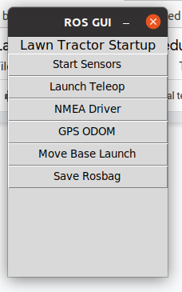

  - Potential error:
    - [ERROR] [1618076938.304149]: Unable to immediately register with master node [http://localhost:11311]: master may not be running yet. Resolution: Check the bash_rc to see if the tractor is the master $ nano ~/.bashrc

  - Step 1 - Launch sensors
    - If you launch the sensors and the low resolution angle sensor value does not display, there is a problem.
    - 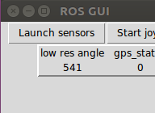
    - 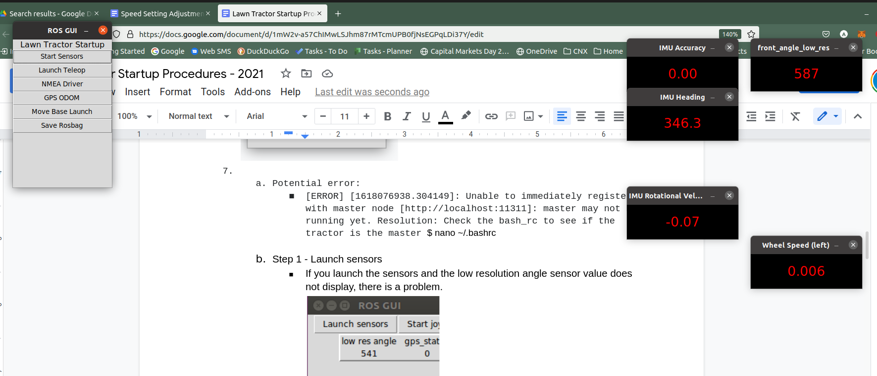
    - if (440 <= current_position_low_res && current_position_low_res <= 640) then the process will continue. If not, you will have to straighten the front wheels.
    - Check to make sure transmission is in neutral (TODO - add transmission reading to GUI)

The PID controller for speed control needs to be re-written. Until that is done the speed control is hard coded to use parameters set in /speed. [3] is the PWM for 0.5-1.0 linear.x; [4] is the PWM for 0.0-0.5 linear.x; - be careful - just pressing the deadman may trigger [4]
1550 = max; 1525 = ~ 1 m/s; 1490 = ~ 0.5 m/s
$ rosparam set /speed "[1000, 1290, 1550, 1525, 1490, 70, 5, 0, 20]"

  - Step 2 - Launch Teleop/Start joystick
    - Click Joystick icon
    - Turn power on 2.4GHz receiver gamepad on and off and confirm the red led comes on
    - Press deadman switch and move joystick steering and transmission control to confirm the tractor is under control. The cmd_speed and angle values should change, the steering wheels should move and the low res angle value should move.
    - 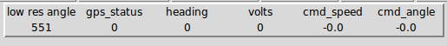
    - If you get this error:
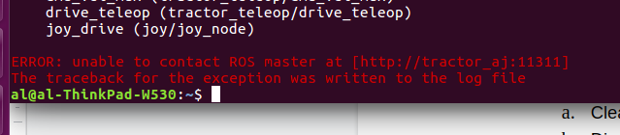
the RPi on the tractor is not functioning correctly. See Debug RPi Network Issues.

IMU - serial_to_ros.py needs to be started - it publishes
pub_imuacc = rospy.Publisher('bno085_imuacc', Float32, queue_size=1)
pub_rotvel = rospy.Publisher('bno085_rotvel', Float32, queue_size=1)
pub_hdg = rospy.Publisher('bno085_heading', Float32, queue_size=1)
pubList = rospy.Publisher('bno085_array', Float32List, queue_size=1)

  - Check joystick control with steering - if the joystick is slow to respond it may be due to the laptop being on one network and the tractor being on another network. You do not want network latency for sensitive steering control functions.
- Step 3 - Start NMEA Driver; Confirm GPS status “2” appears on gui
- Step 4 - Start GPS odom

(At this point start the tractor and move to the starting position)

- Step 5 - MoveBase
  - Adjust the starting position of the tractor in origin statement of the farm.yaml file: origin: [-23.0, -8.0, 0.0] so that it is physically on the correct spot on the map. Stop and restart the simulator as needed.
  - [ x, y, z] = x - left to right, smaller is closer to the left; y - top to bottom, smaller is closer to the bottom
- Confirm steering is under joystick control
- RVIS on the Laptop $ rosrun rviz rviz
- Step 6 - Bagfile

Engage transmission

- Drive with joystick or Tab 6 - RPi: # run a mission
  - $ plink RPI_on_ZeroTier -pw ubuntu
  - {Before next statement - update cmd_vel_input.txt with mission}
  - {Don’t run a mission yet, - Step 9 below runs the mission}
  - $ cd ~/catkin_ws
  - $ rosrun beginner_tutorials meters_travelled_v1.py cmd_vel_input.txt

SHUT DOWN PROCESS:
- REPLACE BATTERY CHARGER WHEN DONE
- Disconnect Fuse to to TRANSMISSION SERVO
- Move bagfiles:
  - Open FileZilla
  - From RPI : /home/ubuntu/.ros/bagfiles
  - To Laptop : /home/al/bagfiles/
  - Delete old bagfiles from RPi
- Delete old log files:
  - From RPI: /home/ubuntu/.ros/log
  - Keep only latest
  - Copy anything you think you should retain
  - $ rosclean check or $ rosclean purge

- $ df # check available disk space - 6/21/20 used 66%
- 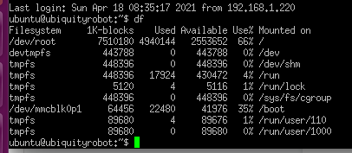
- $ rosclean # another option
- Optional:
  - Turn off USB ports with Teensy’s connected
  - Shut down ROS processes

Things to test/watch as the system matures:

  - Tab 4 - Ubuntu, $ rosrun plotjuggler PlotJuggler
    - Check these data elements to plot
      - Course_over_ground
      - Front_angle_raw #actual
      - Front_angle_target #target
      - Heading
      - Left_speed #actual
      - Left_speed_travelled_msg #delete?
      - Satellite_no
      - Satellite_qual
      - Speed
      - Steer_effort_b4_ra (for debugging)
      - Steer_effort_raw (for debugging)
      - Transmission_PWM
    - File -> Recent Layout -> tractor1.xml # Load previously saved preferences. I have had issues where KLM values were not being published. The resolution was to unplug and reconnect the front_angle

  - Tab 7 - Ubuntu: # {update /steer or /speed as needed}
    - $ rosparam get /speed
    - $ rosparam set /speed "[1000.0, 1290.0, 1600.0, 135.0, -100.0, 70.0, 5.0, 0.0, 20.0]"
    - $ rosparam get /steering
    - $ rosparam set /steering "[-14000.0, 13500.0, 0.0, 60.0, 3.0]"

- Tab 1, Checklist of processes:
  - Teensy - check_rpm publishes /left_speed_avg and prints “left_speed sensor…..”
  - Teensy - speed_control publishes /transmission_PWM and prints “speed_control -...”
  - Teensy - front_anglel publishes /front_angle_klm and prints “front_angle -...”
  - Teensy - steer_control publishes /front_angle_target and prints “steer cmd_vel -...”; plus others
- Tab 7, Check Rostopic are publishing
  - $ rostopic echo /speed
  - $ rostopic echo /nmea_sentence
  - $ rostopic echo /front_angle_raw
Monitor rvis and odom
$ rostopic echo /odom

Take a copy of the
- Tab 5 - $ rosrun tf view_frames && evince frames.pdf (old)
- Try $ rosrun tf2_tools view_frames.py

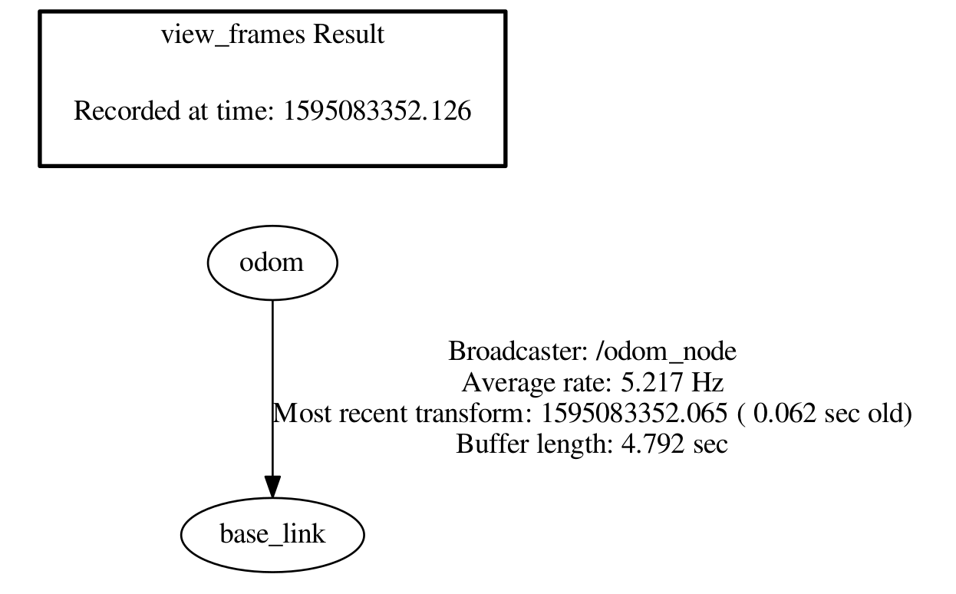

- $ rosrun rqt_graph rqt_graph # save the file with a time stamp for debugging
